EOLab Thesis Proposal – June 2007

Pulse Coupled Neural Networks
For Urban Change Detection

FABIO PACIFICI
f.pacifici@disp.uniroma2.it

Tor Vergata University
Dipartimento di Informatica Sistemi e Produzione
room DT09
Via del Politecnico, 1 - 00133 Rome ITALY
Office. +39 06 7259 7711

Image processing by electronic means has been a very active field for decades. The goal has been, and still is, to have a machine perform the same image functions which humans do quite easily. This goal is still far from being reached. So we must learn more about the human mechanisms and how to apply this knowledge to image processing problems. Within the concepts of artificial neural networks, the neurons are generally simple devices performing summing, thresholding, etc. However, the biological neurons are fairly complex and perform much more sophisticated calculations than their artificial counterparts. The neurons are also fairly specialized and it is thought that there are several hundred types in the brain and messages travel from one neuron to another as pulses.
Recently, scientists have begun to understand the visual cortex of small mammals. This understanding has led to the creation of new algorithms that are achieving new levels of sophistication in electronic image processing. With the advent of such biologically inspired approaches, in particular with respect to neural networks, scientists have taken another step towards the aforementioned goals. The Pulse Coupled Neural Network is a neural network algorithm that produces a series of binary pulse images when stimulated with a grey scale or color image. This network is different from what we generally mean by artificial neural networks in the sense that it does not train.

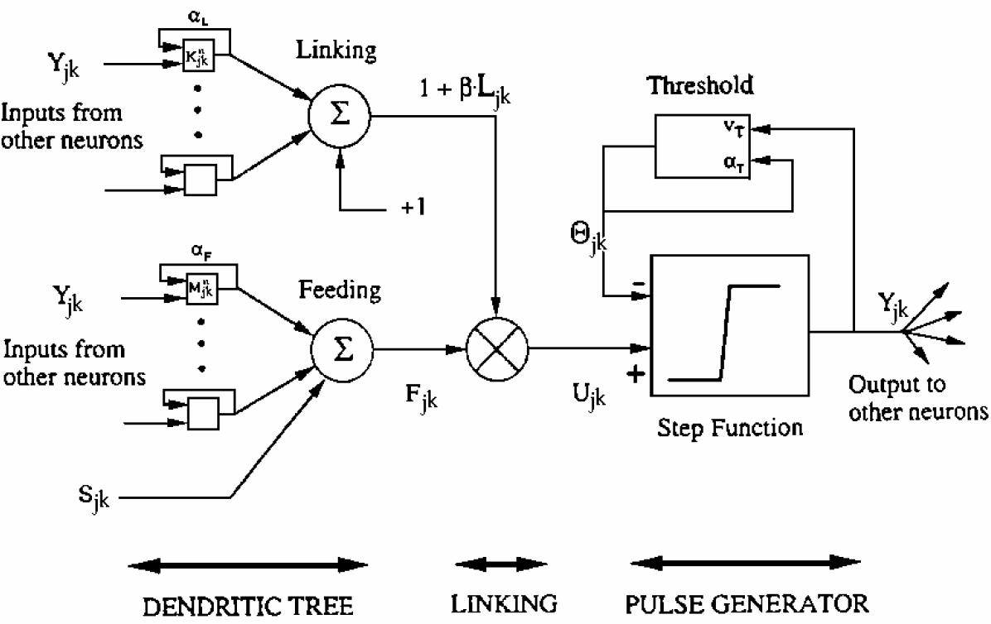

With the increasing availability and improved quality of multi-temporal high spatial resolution satellite data, monitoring detailed urban changes and urban sprawl is becoming possible in a timely and cost effective way. In this context the thesis proposed will address on the development of an unsupervised urban change detection scheme for very high spatial resolution optical imagery (about 60 cm). In fact, understanding growth factors is critical for urban planning, environmental studies, and resource management. Accurate and up to date information on the status and trends of urban ecosystems is needed to develop strategies for sustainable development and to improve the livelihood of cities. With their enhanced spatial resolution, these systems provide more precise information on land use and land cover changes and are being increasingly used to carry out a detailed characterization of the trends of urban areas.

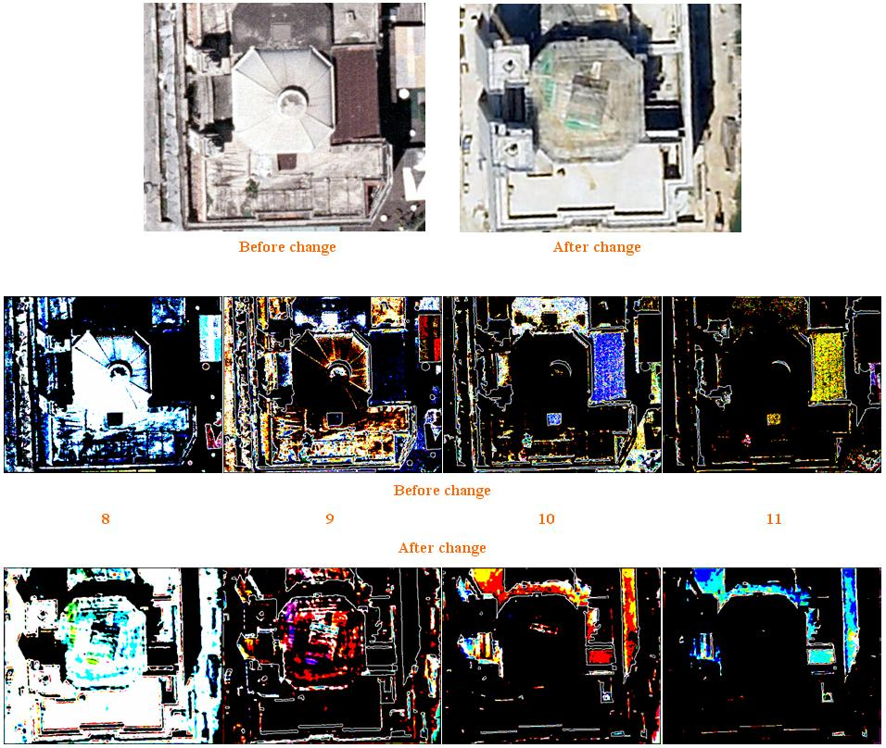

Additional notes:

- the thesis requires about 6 months of work (Laurea Specialistica)
- the thesis will be in English and preferably in LaTeX
- Supervisor: Prof. Fabio Del Frate
- Tutor: Fabio Pacifici

Prerequisites: good knowledge of English

Outcomes:
The student will be able to analyze satellite imagery over urban areas and to interpret the changes occurred. Moreover, she/he will acquire good knowledge of the IDL programming language.

